**Agha Khan Higher Secondary School**

Eligibility Criteria for Admission

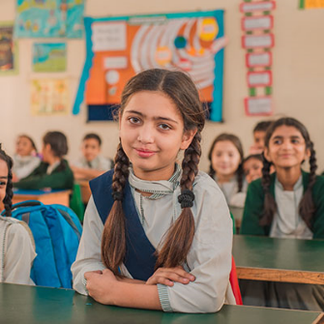Admission to all levels is subject to seat availability. All applicants are required to sit for an admission test.

The admission process starts at the beginning of December each year and closes by the end of December only.Classes for the new academic year start in April.

Application Forms

Application forms are available from the Administration and Students Affairs Office during scheduled dates and time (announced during school admission exercise). To attain the application form, the following documents must be produced:

* Original Birth Certificate as well as two photocopies or Form B
* Three passport-size photographs of the applicant
* School Leaving Certificate from the previous school duly attested by the District Education Office. (Not applicable for pre-primary I class)
* Progress Report Card from the previous class issued by the last school attended. (Not applicable for pre-primary I)

Upon submission, applicants are given an admit card, a copy of the syllabus, and admission test date and time.

Fees

The fee structure is as follows:

**Grade Level Academic Fee ICT Fee**

*Morning Shift*   
Pre-primary I to Grade VIII Rs. 5,270/month Rs. 150

*Morning Shift*  
Grade IX to Grade X  
Science Lab Charges: Rs. 110 Rs. 5,650/month Rs. 150

*Morning Shift*  
Grade XI to Grade XII  
Science Lab Charges: Rs. 160 Rs. 7,660/month Rs. 150

Facilities

School Library

The School has a well-established and modern library with quick and easy Internet access, and books on a variety of subjects and topics.

Computer Laboratory

The school's fully equipped 20-computer laboratory offers students access to audio-visual and printing facilities. The School emphasises education through computers by encouraging students to include web-based research for various class projects and assignments. There are no dedicated computer lessons but teachers give students access to the computer lab when required.

Medical Services

A full-time registered nurse provides first aid treatment, conducts health classes and maintains students' health records.

Health & Safety

To encourage an awareness of essential health and safety issues, the School arranges for doctors and nutritionists to deliver presentations on relevant topics. Topics include ‘Personal Hygiene and Care', ‘Adolescence' and 'ENT Diseases: Prevention and Cure'.

Science Laboratories

For students to clearly develop and understand scientific theories, it is essential to practically experience them. The School has an adequately equipped science laboratory with equipment, apparatus, chemicals and required instruments for Biology, Physics and Chemistry experiments.

Learning Resource Centre (LRC)

Early Childhood Education and Development section has learning corners in the classrooms and a Learning Resource Centre (LRC), which is a place where students and teachers can further explore the resources for their learning. The LRC has a vast collection of books, learning materials, computers and musical instruments where students and teachers can spend their time to enhance their learning along with their classroom activities.

Farm Area

Early Childhood Education and Development section has a farm area where students grow plants and learn about nature by observing the developmental stages of the plants. This enhances students' exploration skills, confidence and caring attitude towards the environment.

Sand and Water Area

Early Childhood Education and Development students love to visit the sand and water area where they enjoy and learn through play and have fun.

Canteen

The School canteen offers a variety of food and snacks for students and teachers at reasonable prices. Food quality is closely monitored by the School administration.

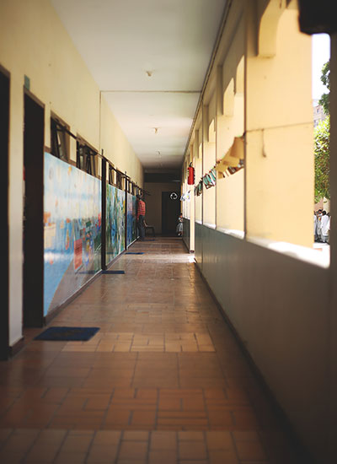

## About the Aga Khan Education Services

The Aga Khan Education Service (AKES) was created by Sir Sultan Mahomed Shah Aga Khan, the current Aga Khan's predecessor and grandfather. Aga Khan Schools were first established as early as 1905. These included a handful of community-based literacy classes in remote rural areas of South East Asia which were strikingly progressive for their time. They put emphasis on accessibility for all communities regardless of socioeconomic status, teaching both girls and boys, and stressing the importance of equitable early childhood education.

Today, the Aga Khan Education Services is one of the largest private, not-for-profit, non-denominational educational networks in the developing world. AKES currently operates over 200 pre-primary, primary, secondary, and higher-secondary schools and programmes in Afghanistan, Bangladesh, India, Kenya, Kyrgyzstan, Pakistan, Tajikistan, Tanzania, Uganda and the United Arab Emirates. Programmes include affiliation with rigorous national curricula and international curricula such as the International Baccalaureate, Cambridge International Education and the Aga Khan University-Examination Board (AKU-EB) programmes. The schools have been an exemplar of progressive education in the regions within which they operate, with a continued emphasis on child-centered learning, teacher training and education for girls. AKES has been a leader in these areas for over a hundred years.

Our goal is to provide quality education that prepares students to thrive personally and professionally. Our programmes embody AKES’ commitment to service, not just in the school, but to the neighbouring community and beyond.

Our extensive reach, progressive programmes and emphasis on inclusivity create a positive, permanent impact on the students, teachers, parents, alumni, and communities we serve.